**SOFTWARE SETUP**

**For More Information Call or WhatsApp Us on: 08030511988**

NOTE: Before installing the Payment Management Application Software, ensure you have downloaded and installed WAMP Server 2.4 on your system

**INSTALLING SOFTWARE FROM THE CD DRIVE OR FLASH DRIVE**

Step 1: Insert and Open you Compact Disk (CD)

Step 2: Copy the “**student-record-data-storage-model”** folder and paste in your wamp server

Path to Paste the folder: **C:\wamp\www\**

C:\Users\CARSON\Desktop\asas.JPG

Step 3: Turn on your Window Apache MySQL and PHP

(WAMP Server 2.4)

Step 4: Open your browser e.g Mozilla Firefox, Google Chrome.

Step 5: Type in this URL below on your address bar of your browser

**localhost/phpmyadmin/**

Step 6: Ensure the username is **root** and password is empty before clicking on **Go** button

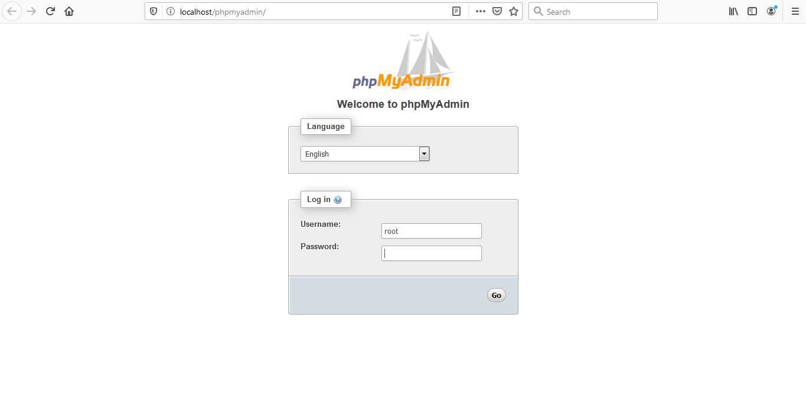

Step 7: Click on Import and Browse your computer to search for advisory.sql

Path: **C: \wamp\www\student-record-data-storage-model\db**

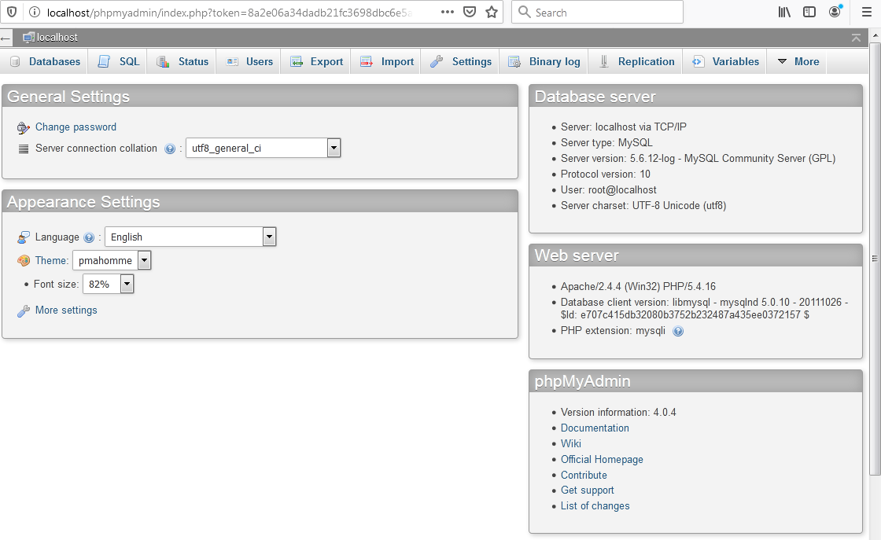

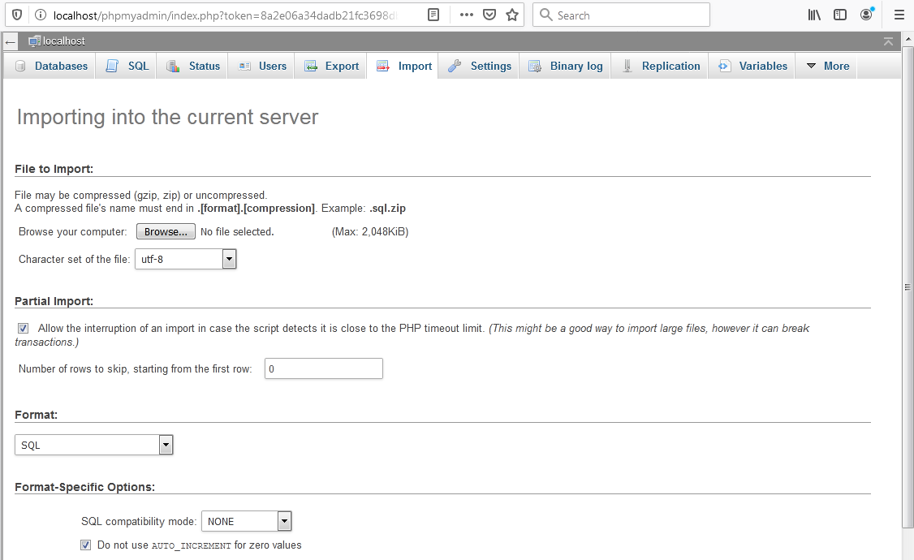

Step 8: Click and open on **advisory**, then click on **Go** button below the import page.

Step 9: Type in this URL below to execute the Software

**127.0.0.1/student-record-data-storage-model/**

Step 10: You’re done

**RE-EXECUTING THE SOFTWARE AFTER INSTALLATION**

Step 1: Start your WAMP Server

Step 2: Open your browser and type in the URL below and click enter

**127.0.0.1/student-record-data-storage-model/**